**JobsBridge.com – Recruiter**

**Objective**

Building JobsBridge as an integrated social recruiting platform. Enabling recruiting candidates by using social platforms as talent databases for advertisements and seek applications.

Cast your jobs in a click, Connect all recruitment platforms in one go!



Table of Contents

1 Concept Introduction 5

1.1 Project Overview 5

1.1.1 Key Benefits 5

1.1.2 Mobile Responsive Design 7

1.1.3 Site Flow 8

1.1.4 Pages/Screens 8

2 Product Functional 9

2.1 Landing Page 9

2.1.1 Jobseeker Features 10

2.1.2 Job Seeker Registration 10

2.1.3 Job Search & Apply 11

2.1.4 Job Description Page 12

2.1.5 Application Confirmation Page 13

2.1.6 Job Seeker Login and Apply 13

2.1.7 Job Seeker Dashboard 14

2.1.8 Job Seeker Profile Page 14

2.1.9 Job Seeker Insights 15

3 Employer Features 16

3.1 Social Recruiting Solution 16

3.1.1 Social Sharing & Post Social Job Ads 16

3.1.2 Referral Program 16

3.1.3 Social Applications and ATS Integration 16

3.1.4 Create your own social talent Pool 17

3.1.5 Employer Login 18

3.1.6 Employer Dashboard 19

3.1.7 Employers Search Form 19

3.1.8 Employers Search Results Page 20

3.1.9 Employers Resume Detail Page 21

3.1.10 Employers Job Posting Page 22

3.1.11 Employers Manage Jobs Postings Page 22

3.1.12 Employers Application Management Section 23

3.1.13 Employers Reports Section 23

# Concept Introduction

## Project Overview

The new version of JobsBridge will now be leveraging the power of social recruiting with the objective of gaining greater insight into a candidate’s skills and experience.

Gaining greater insight into prospective candidates is crucial during the recruitment process, and creating a more holistic picture of an individual is one such way in which to achieve this.

### Key Benefit

**Employer**

* Connect all your job sites login
* Shares Ads posting on social sites
* Jobs Sharing on Diff Job Portals
* Get applications from Social Sites
* Do ATS integration
* Search candidates from across job portals

**Employer Social Integration**

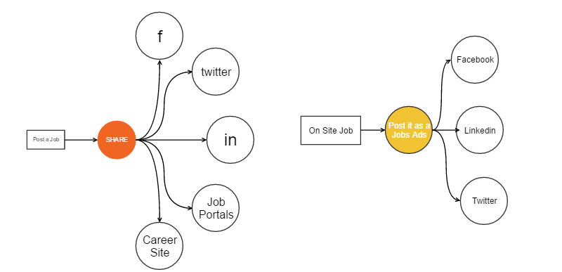

**Employer Social Integration**

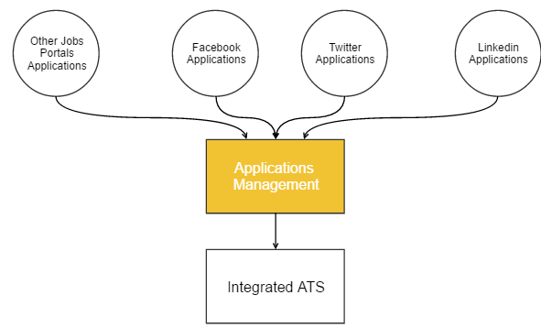

### Mobile Responsive Design

The new site will be totally responsive. Being totally focusing on **social recruiting**, mobile traffic place plays a very important role. We will initially make a responsive site. Eventually mobile app will be make for mobile users.

Currently, more than 58% of American adults own a smartphone and almost 60% of all website traffic is from mobile devices.

**Social media increases mobile visitors**

Over 55% of social media consumption now happens on mobile devices, so sharing links from social media sites like, Facebook, YouTube, Twitter, or Google Plus to your website will mean even more traffic and viewing of your website from mobile devices.

Ref: <http://www.marketpath.com/digital-marketing-insights/8-reasons-to-have-a-responsive-web-design-infographic>



### Site Flow

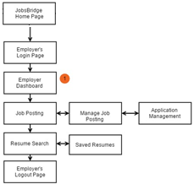

### Pages/Screens



# Product Functional

## Landing Page

The site landing page will be equipped with direct Jobs Search, Seeker login, Top Jobs, top Employers. Employers login option will upfront redirecting them to employer’s login page.

**Page Elements:**

* Job Seeker Login
* Employer Login
* Jobs Seeker Benefits
* Employer Benefits
* Site Features – USP’s
* Top Employers

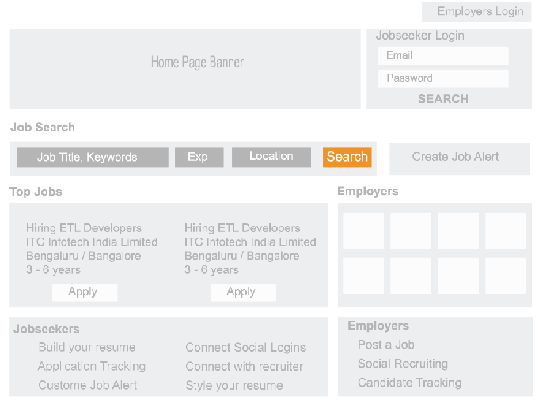

# Employer Features

## Social Recruiting Solution

### Social Sharing & Post Social Job Ads

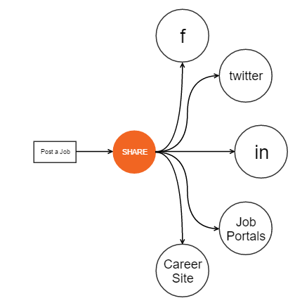 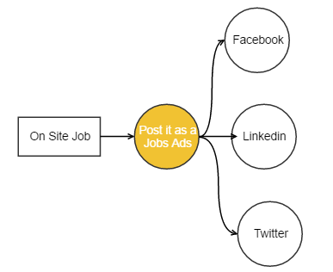

### Easy Sign Up & Login

Social login will be enabled for the recruiters.

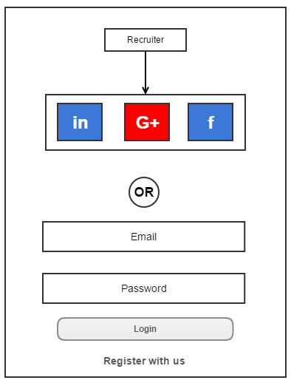

**Recruiter Registration**

Easy social login registration. Select your package and pay. This will be a small 3 step process for recruiter on-boarding.

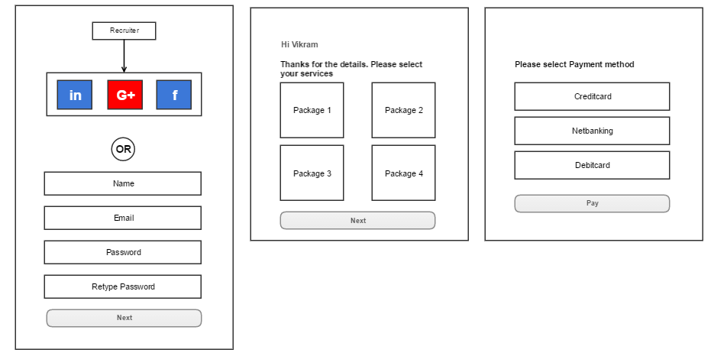

## Recruiter Seeker Search

Recruiters will be able to search candidate from across the job portals. For eg searching for “Java” will fetch profiles from all the job portals.

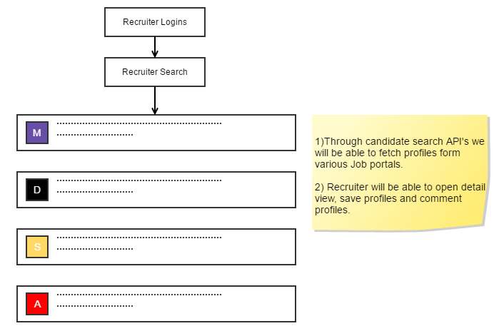

**Assumption: Candidates Search API will be provided for desired job portals through which we will be fetch seeker profiles.**

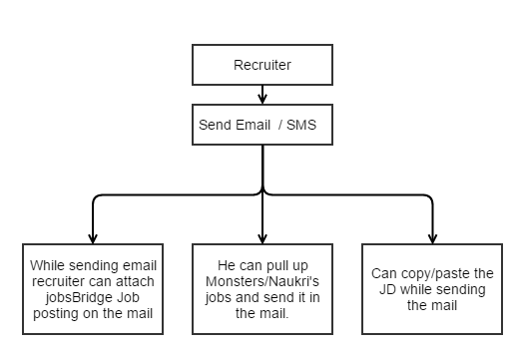

Other than Email /SMS recruiter will be able to Save, Comment, shortlist, flag respective seekers resumes. All this info will be stored on jobsbridge side.

**Recruiter Jobs posting**



**Note: For tied up job portals we will be able to push jobs directly. Recruiter will be able to share these jobs on his connected social logins in one go.**

### Social Applications and ATS Integration

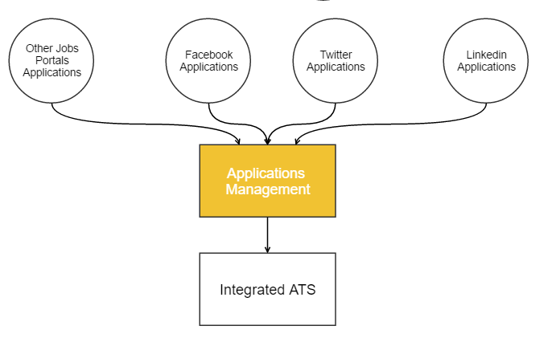

### Create your own social talent Pool

Recruiter will be able to extract prospect candidates social profile and link it to existing profile. Google chrome plugin will be made to extract and link profile.

* Recruiters can store candidate profile for Facebook, LinkedIn, Twitter in their talent pool.
* Email Messaging
* Social Finder to get access to profile and add them - Automated Social Media Aggregation
* Create diff talent Pools
* ATS integration

### Employer Login

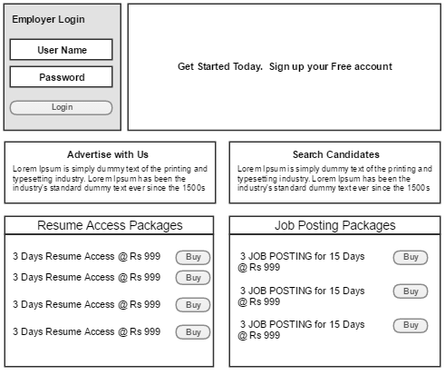

### Employer Dashboard

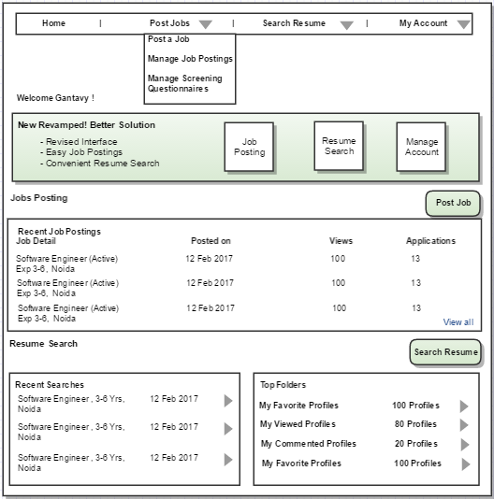

### Employers Search Form

Standard single page search form will be designed for candidate Search.

Form Elements

* Keyword
* Experience
* Location
* Education
* Salary
* Company

### Employers Search Results Page

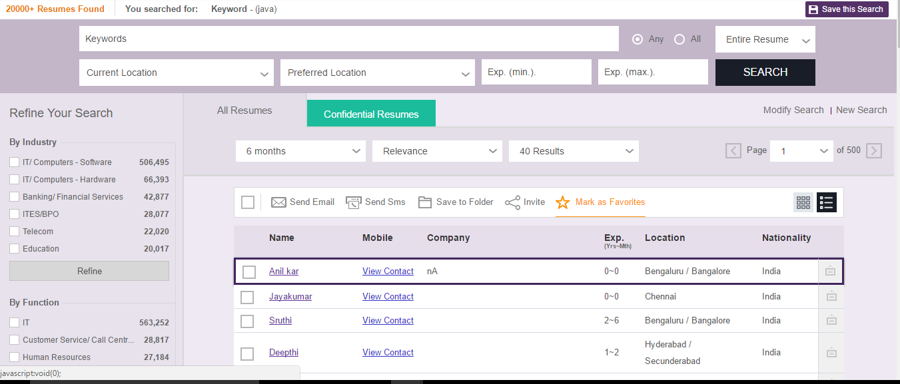

### Employers Resume Detail Page

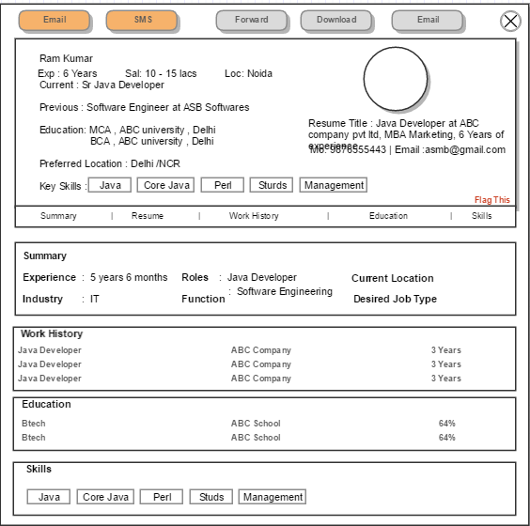

### Employers Job Posting Page

Standard single page job posting form will be available with the following fields

* Job Title
* Jobs Description
* Summary
* Exp, Keyskills
* Scheduling
* Industry, Function, Location

### Employers Manage Jobs Postings Page

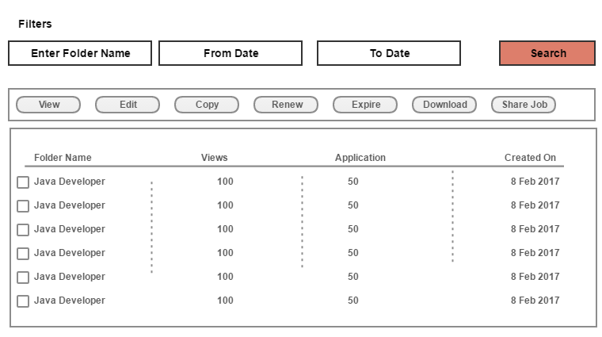

### Employers Application Management Section

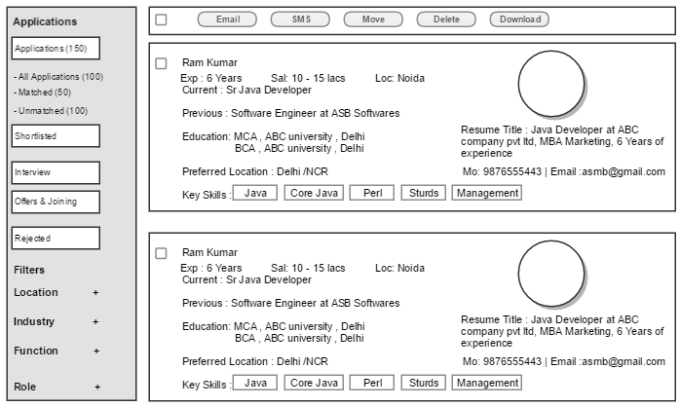

### Employers Reports Section

Standard reporting’s will be available in the module

* Database access
* Posting Report
* Email Sent
* SMS Sent